Software Requirements and Design Document

Blood Bank Management System
Prepared by: Waiz Hassan Zubairi
Dated: 03-Dec-23
Table of Contents
1. Introduction 1
1.1 Purpose 1
1.2 Product Scope 1
1.3 Title 1
1.4 Objectives 1
1.5 Problem Statement 1
2. Overall Description 2
2.1 Product Perspective 2
2.2 Product Functions 2
2.3 List of Use Cases 2
2.4 Extended Use Cases 3
2.5 Use Case Diagram 16
3. Other Nonfunctional Requirements 17
3.1 Performance Requirements 17
3.2 Safety Requirements 17
3.3 Security Requirements 17
3.4 Software Quality Attributes 18
3.5 Business Rules 18
3.6 Operating Environment 18
3.7 User Interfaces 19
4. Domain Model 19
5. System Sequence Diagram 20
6. Sequence Diagram 32
8. Class Diagram 38

Introduction

Purpose
The software requirements specified in this document apply to the Baiz Blood Bank Management System, which was identified with revision [1.0]. A large part of this system includes blood donors, hospitals and blood banks. It aims to automate and improve blood storage, making blood availability more accessible and efficient. This SRS document describes the entire system, including activities for providers, suppliers, hospitals, and blood banks.

Product Scope
The Baiz Blood Bank Management System is designed to streamline and improve the blood donation and collection process, focusing on donor and recipient information, blood registration, and its distribution This process aims to provide an effective solution to a critical challenge in a timely manner. In keeping with the broader goal of saving lives, the ultimate goal is to help provide blood to those in need. This document is a comprehensive guide to the software requirements of the system.

Title
The project is aptly named the "Baiz Blood Bank Management System", reflecting its objective of providing immediate and effective solutions to challenges faced in blood bank systems The system seeks to provide seamless communication among them facilitate donor-consumer communication to increase blood availability for patients in need.

Objectives
The key objectives of the Badge Blood Bank Management System project include:
- Automated and optimized blood banking systems.
- Make it easy to document providers.
- Simplifying the process for patients who need to donate blood regularly.
- Assist donors and clients in soliciting donations.

Problem Statement
Medical tragedies often require immediate blood donation, but obtaining compatible and accessible blood is still a difficult process Badge Blood Bank Management System solves this problem with an automated blood bank system reducing productivity, reducing the risk of errors, improving overall efficiency Timely and is to ensure delivery

Overall Description

Product Perspective
The Badge Blood Bank Management System is designed as an independent and comprehensive solution designed to revolutionize the management of blood donation programs. This software is not part of the existing product family but is designed as a stand-alone system. It is an important resource for blood banks, hospitals, donors and clients. Although it works in isolation, it seamlessly integrates with larger health information systems and also establishes networks for exchanging data to ensure consistency with broader medical practice.

Product Functions
The Baiz Blood Bank Management System is designed to perform a range of key functions to ensure efficient blood banking processes. The major functions include:
- Donor Management:
- Capture and maintain detailed donor information.
- Track donor eligibility and participation in regular blood donation.
- Receiver Management:
- Capture and maintain detailed receiver information.
- Track receiver illness in regular blood receiving.
- Inventory Management:
- Monitor blood inventory levels and expiration dates.
- Automate the categorization and storage of different blood types.
- Distribution:
- Facilitate the timely distribution of blood units to hospitals and medical facilities.
- Prioritize distribution based on urgency and compatibility.
- User Authentication and Authorization:
- Ensure secure access to the system with role-based permissions.
- Maintain an audit trail for user actions within the system.
- Record-Keeping and Reporting:
- Generate comprehensive reports on blood inventory, donor statistics, and distribution history.
- Facilitate easy record-keeping of donor history and recipient details.

List of Use Cases
- Registration (Donor + Receiver + Organization)
- Donation Scheduling
- Receiving Scheduling
- Inventory Management
- Equipment Management
- Storage and Preservation
- Blood Request
- Money Donation
- Testing and Screening
- Billing and Payment
- Distribution and Allocation
- Staff Management

Extended Use Cases
USE CASE 1
Use Case Name: Registration

Scope: Blood Bank Management System

Level:Primary

Primary Actor: Donor, Receiver, Staff

Stakeholders and Interests:
- Receiver: Interested in getting blood from a donor
- Donor: Interested in becoming a registered blood donor.
- Blood Bank Staff: Responsible for managing donor registrations and ensuring blood safety.

Preconditions: User has not already been registered

Postcondition: User's information is successfully registered in the system, and he/she becomes a registered member.

Main Success Scenario:

User | System Response
User access the registration option | System displays the registration screen to enter personal information.
User Provide Full Name, Contact Details, Date of Birth, Password, Blood Type, Medical History, Agree to terms and conditions | System validates the entered information for correct format and correctness. Verification code is sent to user email id
User enter the confirmation code | System assigns a unique id to the user and redirects the user to system.
Extension:
- If the information is incomplete or invalid, the system will display an error message and prompt user to enter correct information
- If email verification fails then system informs user and prompt them to reenter the code

USE CASE 2
Use Case Name: User Login

Scope: Blood Bank Management system

Level: Primary

Primary Actor : User, Staff

Stakeholders and Interests:
- User: Interested in accessing system
- Admin: Access system to manage the system
Preconditions: The user is registered on system

Postcondition: User successfully gain access to their account

Main Success Scenario:

User | System Response
User opens the system | System display the login screen to enter credential
User enter his email and password | System validates the credential and give access of the account to the user

Extension:
- If there are repeated failed logins, the app locks the account.
- User can initiate forget password by clicking “Forget password” button

USE CASE 3

Use Case Name: Inventory Management

Scope: Blood Bank Management system

Level: Primary

Primary Actor : Blood bank staff/ Admin

Stakeholders and Interests:
-Staff: Interested in maintaining the inventory
-Admin: Responsible for app maintenance

Preconditions: Staff is logged in on the system with the credentials

Postcondition: The inventory is successfully managed

Main Success Scenario:

User | System Response
User logged in on the system | System display the dashboard with option “Inventory Management”
Staff selects “Inventory Management” | System display a list of actions like blood type, Quantity, Storage, Location,
Staff select blood types | System shows all the Labeled and unlabelled blood stock
Staff update the unlabelled stock and select save | System update the new data

Extension:
- If the temperature readings are outside of acceptable range then system will give a warning to the user
- If the user enter another label to blood then user will be prompted to enter correct blood type

USE CASE 4

Use Case Name: Donation Scheduling

Scope: Blood Bank Management system

Level: Primary

Primary Actor : Donor, Staff

Stakeholders and Interests:
Donor: Interested in convenient time for doating
Staff: Responsible for managing Donations

Preconditions: Donor is logged in onto the system

Postcondition: A donation is successfully scheduled

Main Success Scenario:

User | System Response
User logged in on the system | System display the dashboard with option “Schedule Donation”
Staff selects “Schedule Donation” | System display Donation Schedule form
Donor fulfill the form and submit the form | App ask for user for confirmation
Donor confirm the appointment request | System update the donor account with this appointment Information

Extension:
- If the preferred time is not available for the user then app will suggest other time for user
- If the user cancels the appointment, then he will be returned to the dashboard.

USE CASE 5

Use Case Name: Receiving Scheduling

Scope: Blood Bank Management system

Level: Primary

Primary Actor : Receiver, Staff

Stakeholders and Interests:
Donor: Interested in donation of blood
Receiver: Interested in receiving donation of blood

Preconditions: Donor is logged in onto the system and a donor has added the request

Postcondition: A donation is successfully scheduled and done

Main Success Scenario:

User | System Response
User logged in on the system | System display the dashboard with option “Schedule Blood Reception”
Staff selects “Schedule Blood reception” | System display reception Schedule form
User fulfill the form and submit the form | System check for availability for blood donors
User confirm a donor option | System update the account with this appointment Information and send a confirmation message to donor

Extension:
- If the preferred time is not available for the user then app will suggest other time for user
If match blood is not present then the system send a prompt that blood is not available

USE CASE 6

Use Case Name: Storage and preservation

Scope: Blood Bank Management system

Level: Primary

Primary Actor : Staff

Stakeholders and Interests:
-Donor and Patient: Rely on blood bank for blood
- blood Bank Staff: Interested in maintaining quality and safety

Preconditions: Staff is logged in on system

Postcondition: Storage is according to the quality standard

Main Success Scenario:

User | System Response
User logged in on the system | System display the dashboard with option “Storage and preservation”
Staff selects “Storage and Preservation” | System display a list of blood units with their data like quantity, expiration date, Location
Staff sees the unit which require action | System shows the action which could be taken
Staff make the necessary changes | System is updated

Extension:
- If required blood unit is not found then a prompt will be sent to user

USE CASE 7

Use Case Name: Donation request ( Blood Request) = ( That if we need that blood group blood or we have that blood group blood).

Scope: Blood Bank Management system

Level: Primary

Primary Actor : Patient/ receiver, Staff

Stakeholders and Interests:
Donor: Interested in convenient time for doating
Receiver: Interested in receiving donation of blood

Preconditions: Receiver is logged in onto the system

Postcondition: A donation request is successfully scheduled

Main Success Scenario:

User | System Response
User logged in on the system | System display the dashboard with option “Add blood Request”
User selects “Add Blood Request” | System display Request form
User fulfill the form and submit the form | App ask for user for confirmation
Donor confirm the appointment request | System update the USer account with this appointment Information and send a donation request to all the eligible donors

Extension:
- If no eligible donor is shown then the system will send a message to the user
- If the user cancels the request, then he will be returned to the dashboard.

USE CASE 8

Use Case Name: Distribution and Allocation

Scope: Blood Bank Management system

Level: Primary

Primary Actor : Staff

Stakeholders and Interests:
Staff: Interested in efficient distribution of blood

Preconditions: Staff should be logged in and blood quantity is present in inventory for distribution

Postcondition: Blood is allocated to preferred place

Main Success Scenario:

User | System Response
User logged in on the system | System display the board with option “Distribution and Allocation”
User select “Distribution and Allocation” | System displays all the available inventory which can be delivered and asks the user to select an option.
User enter the amount he need, the location he need from and location for delivery | App ask for user for confirmation
User make the confirmation | System updates the database and make a invoice for order

Extension:
- User enter the more than available amount of blood for quantity, So system will send a prompt to enter the right amount or exit the system

USE CASE 9

Use Case Name: Money Donation

Scope: Blood Bank Management system

Level: Primary

Primary Actor : Donor

Stakeholders and Interests:
Donor: Interested in making a financial donation
Staff: Responsible for processing and managing monetary donation

Preconditions: Donor should be logged in

Postcondition: Donations are successfully transferred from donor to blood bank

Main Success Scenario:

User | System Response
User logged in on the system | System display the board with option “Make a Donation”
User select “Make a Donation” | System displays a form with all the information for the donation
User enter the information about donation into the form | System validate the information and then send a prompt to enter the transfer details
User enter the transfer details | System validates the details and send a thank you message to user

Extension:
- User enter the wrong transfer details so system sends a swat team to kill their whole family

USE CASE 10

Use Case Name: Equipment Maintenance

Scope: Blood Bank Management system

Level: Primary

Primary Actor : Staff

Stakeholders and Interests:
Staff: Relies on properly functioning Equipment for work
Preconditions: Staff should be logged in

Postcondition: Maintenance Request is successfully added

Main Success Scenario:

User | System Response
User logged in on the system | System display the board with option “Add maintenance request ”
User select “Add maintenance request ” | System display a maintenance form
User enter the information like Equipment id etc. into the form | System validates the information , creates a request for and creates a request id for maintenance .

Extension:
- Users enter the wrong equipment details so the system sends a prompt to enter correct information.

USE CASE 11

Use Case Name: Testing and Screening

Scope: Blood Bank Management system

Level: Primary

Primary Actor : Donor, patient
Stakeholders and Interests:
Blood Donor: Interested in making sure that his blood is good for donation
Receiver/Patient: Making sure that correct blood is received for transfusion.

Preconditions: User should be logged in and Blood bank has their sample for testing

Postcondition: User get their blood test

Main Success Scenario:

User | System Response
User logged in on the system | System display the board with option “Blood Test ”
User select “Blood Test ” | System display another board with option “Apply for screening” and “Check test result”
User select for “Apply for Screening” | System Show a form to fill which ask about user ID
User enter the ID | System add the request and gives a result ID to user

Extension:
- Users select the option “Check Test result” then system gives a prompt for ID, user enters his result ID and system gives a detail about result.
- User enter the wrong user ID so system prompt to enter the user ID again

USE CASE 12

Use Case Name: Billing and Payment

Scope: Blood Bank Management system

Level: Secondary

Primary Actor: Donor, patient

Stakeholders and Interests:
Blood Donor/Patient: Interested in making sure that he has paid for screening and test

Preconditions: User has already applied for test and screening

Post condition: Payment is successful

Main Success Scenario:

User | System Response
User has applied for test | System display a form for payment option
User fill out the form | System validate the information and then send a prompt to confirm the transfer
User enter the ID | System add the request and gives a result ID to user

Extension:
- User enter wrong transfer details and system send a prompt to enter the correct information

Use Case Diagram

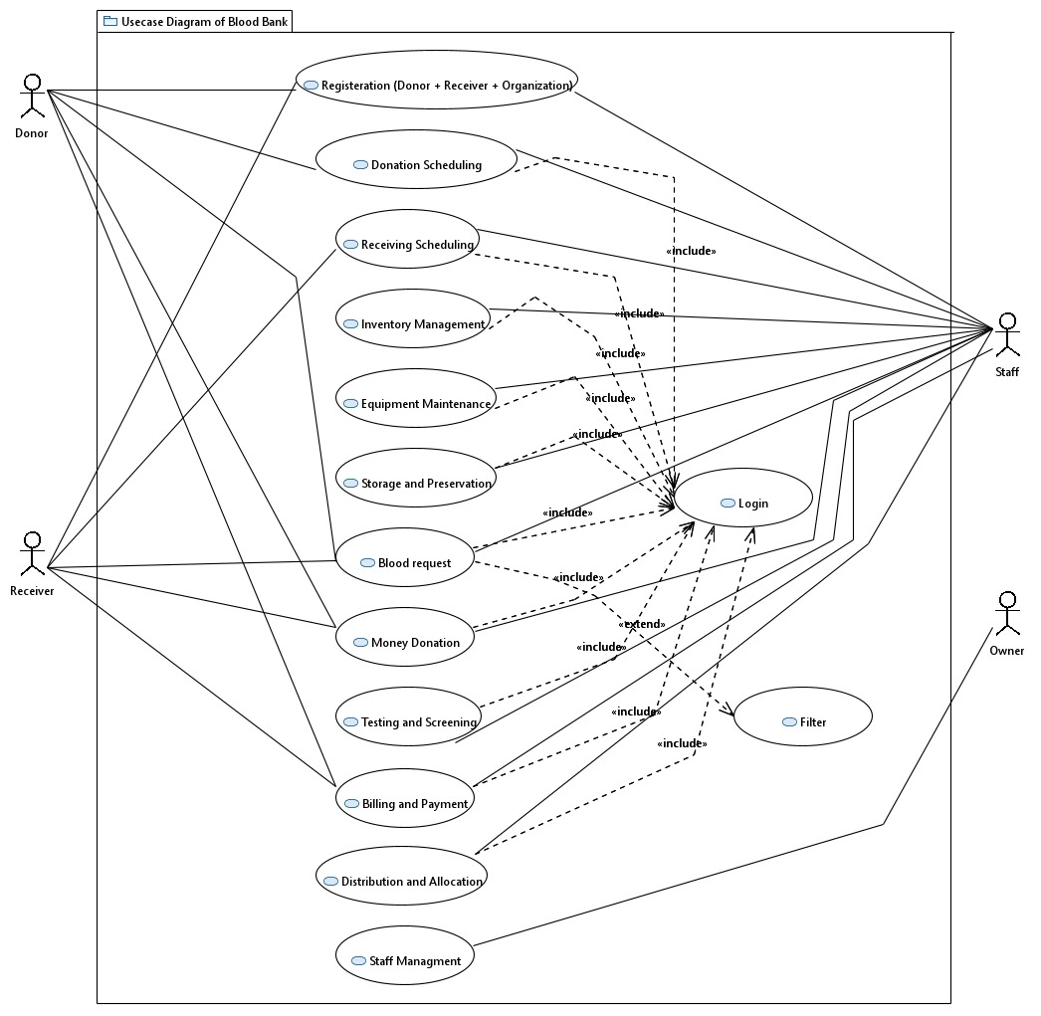

Other Nonfunctional Requirements

Performance Requirements
The Baiz Blood Bank Management System is expected to demonstrate robust performance under various circumstances. Performance requirements include:

- Response Time:
  - The system should respond to user queries and transactions within 2 seconds to ensure a seamless user experience.
- Scalability:
  - The system should efficiently handle an increasing number of users, donors, and blood bank transactions as the database grows.
- Throughput:
  - The system should support a minimum of 100 concurrent user sessions, ensuring timely access for all users during peak periods.

Safety Requirements
Safety is a paramount concern in the Baiz Blood Bank Management System:

- Data Integrity:
  - Safeguards must be in place to prevent data corruption and ensure the integrity of donor and recipient information.
- User Authentication:
  - Strict user authentication protocols are required to prevent unauthorized access to sensitive data.

Security Requirements
Security measures are crucial to protect the confidentiality and integrity of sensitive information:

- Data Encryption:
  - All data transmission between users, blood banks, and hospitals must be encrypted to prevent unauthorized access.
- User Authorization:
  - Access to different modules and functionalities should be role-based, ensuring that users only have access to information relevant to their responsibilities.

Software Quality Attributes
The Baiz Blood Bank Management System must exhibit the following quality attributes:

- Reliability:
  - The system should operate without critical failures, ensuring uninterrupted blood banking operations.
- Usability:
  - The user interface should be intuitive and user-friendly, promoting ease of use for all stakeholders.
- Maintainability:
  - The system should be designed for easy maintenance, facilitating updates and enhancements.

Business Rules
- Donor Eligibility:
  - Only eligible donors, meeting specified health criteria, should be allowed to contribute blood.
- Distribution Prioritization:
  - Blood distribution should prioritize urgent cases, ensuring timely response to critical medical needs.

Operating Environment
The Baiz Blood Bank Management System is designed to operate in the following environment:
- Hardware Platform:
  - The system is compatible with standard server configurations.
- Operating System:
  - The system supports Windows Server 2016 and later versions.
- Software Components:
  - The system must coexist with database management systems, web servers, and any additional software required for its operation.

User Interfaces
The user interfaces in the Baiz Blood Bank Management System will be designed with the following considerations:
- Intuitive Design:
  - Screens should be designed for ease of use, with logical layouts and intuitive navigation.
- Standard Buttons and Functions:
  - Common functions, such as search, submit, and cancel, should follow standard conventions for consistency.
- Error Message Display:
  - Error messages should be displayed in a clear and user-friendly manner, providing guidance for issue resolution.

Domain Model
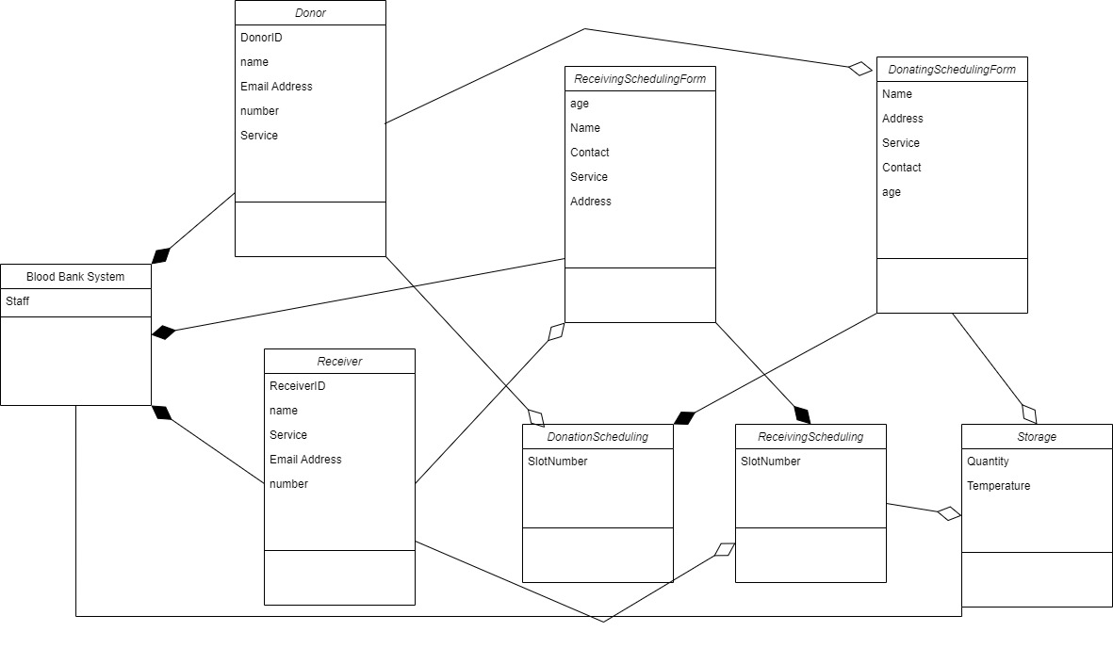

System Sequence Diagram

Sequence Diagram

2. Donation Scheduling

3. Payment

4. Registration

5. Storage and Preservation

- Testing and Screening

Class Diagram

